2ND DISTRICT VIRTUAL LEADERSHIP CONFERENCE
“ASSAULT ON ILLITERACY”
and
10th ANNUAL GAME CHANGER CONFERENCE for
FATHERS, MOTHERS, BOYS AND GIRLS
SATURDAY, FEBRUARY 27, 2021
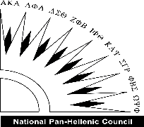
9:00 A.M. – 1:30 P.M.
CONFERENCE THEME: MENTORING IN THE MIDST OF A CRISIS
This is an annual one-day virtual mentor conference geared toward black and brown students of color: Grades 3–5 (Elementary School), Grades 6–8 (Middle School), and Grades 9–12 (High School). Over the past nine years, the conference has grown to impact the lives of more than five-thousand students in Montgomery County, Maryland, and the surrounding metropolitan area. Wow, what an impact!
The purpose of the one-day mentoring conference is to bring together stakeholder groups (students, parents & community leaders/supporters) and bring awareness to the challenges faced by young black and brown students of color, especially our male students who are striving to be a success story, even in the midst of learning in the virtual environment due to the globe COVID-19 pandemic, in addition to the backdrop of social and political unrest.
Part I of the first virtual Game Changer Conference was held on Saturday, October 24, 2020, and Part II of the virtual Conference, which is open to families, will occur on Saturday, February 27, 2021. Mentors, coaches, dads, uncles, mothers, guardians, church organizations and Omega Men/Chapters are encouraged to register their young students for the conference! There will be workshops for everyone.
REGISTRATION SITE: www.TheGameConference.org
Dads, moms, guardians, mentors, church youth leaders, coaches, anyone working directly with youth, please register your student(s) ASAP. To enable breakout sessions, each person attending the conference needs to be registered (this means that you will need to go through the registration process for each person attending, listing the applicable email address for the person being registered).

Register online at: www.TheGameConference.org
OR at https://zoom.us/meeting/register/tJUqcOuqrT4sHdI45ANcwwpBP-GL6NOGfoTo

After registering, you will receive a confirmation email containing information about joining the meeting.

RELEASE AND WAIVER OF LIABILITY
All that register acknowledge Waiver Statement as reflected below.
I release, waive and hold harmless UCF, its owners, directors, officers, employees, agents, teaming partners, coaches and independent contractors (hereinafter referred to as “released parties”), from any liability or claim resulting from any bodily injury, personal injury, illness, death, or property damage that my child may incur as a result of participating in UCF-sponsored activities. I also agree to indemnify, hold harmless and defend UCF and all released parties against any and all claims, demands, losses, causes of action, damage, lawsuits, judgments, including attorneys' fees and costs that may arise from, or as the result of, the conduct of my child in connection with UCF-sponsored activities.
Also, I grant consent to full permission and rights to use, without compensation, photographic and/or video images taken of, or quotations provided by, my child relating to his/her participation in UCF-sponsored activities in brochures, websites, advertisements, and other marketing materials for UCF.

Students we are giving away plenty of gifts!
POEM CONTEST:
Students you are highly encouraged to compete in the Poem Competition. You need to memorize a poem from the following list below and submit your written thoughts on the poem’s meaning, life application and explain why it is imperative to your educational advancement to take the current virtual learning experience seriously. To name a few: Invictus, See it Through, Live Your Creed, The Bridge Builder, Mother To Son, Gentleman, Still I Rise, Our Deepest Fear, The Hill We Climb. Please submit your writing to: lorenzoprillman@gmail.com, aimhighinlife@aol.com.
CONTEST PRIZES: 1st Place ($100.00 Amazon E-Card); 2nd Place ($75.00 Amazon E-Card); 3rd Place ($50.00 Amazon E-Card); 4th Place ($25.00 Amazon E-Card).
FOUNDING ORGANIZATION:
UCF “Aim High-In-Life” Youth Development Organization, enters fifteen years of “promoting student success and changing lives in the community one student at a time amongst at-promise youth.” Saving and Shaping Young People Lives! (www.ucfinc.org)
COMMUNITY PARTNERS:
Mu Nu Chapter of Omega Psi Phi Fraternity, Inc., celebrates 50 years of leadership excellence in Montgomery County Maryland with community engagement activities such as the George B. Thomas Learning Academy, Omega Psi Phi Fraternity, Inc. Achievement Week, Bridge Builder Mentoring Program, and the Fatherhood partnership with HOC. (www.munuques.org)
Montgomery County Public School System, Office of Student and Family Support and Engagement.
Montgomery College (A Partnerships for Interfaith and Community Service - MC-PICS) The Universities at Shady Grove offers career-oriented higher education courses to residents of Montgomery County, Maryland and its surrounding region.
The National Pan-Hellenic Council of Montgomery County is a collaborative umbrella organization composed of historically African American Greek-lettered fraternities and sororities. The NPHC organizations are sometimes collectively referred to as the “Divine Nine.
2ND DISTRICT VIRTUAL LEADERSHIP CONFERENCE “ASSAULT ON ILLITERACY”
10 ANNUAL GAME CHANGER CONFERENCE FOR FATHERS, MOTHERS, BOYS AND GIRLS
MASTER OF CEREMONY: Brother Dr. Lorenzo Prillman
TIME | BREAKOUT GOURPS | GAME CHANGER CONFERENCE SESSION
8:30 a.m. – 8:50 a.m. | WHOLE GROUP | Remarks from U.S. Senator Jim Clyburn (Video)  U.S. Senator Chris Van Hollen (Video)  M.L.K. Jr. Speech – How to Design Your Life Blueprint (Video)  Game Changer 2018 Conference Promotion Video
8:50 a.m. –  9:00 a.m. | WHOLE GROUP | Welcome & Overview  2nd District Chaplain – Reverend Dr. Ronald Williams  37th District Representative – Brother Kelvin Ampofo
9:00 a.m. 9:20 a.m. | WHOLE GROUP | Brian Heat – Motivational Speaker  http://brianheat.com/bh-presskit.pdf
9:30 a.m. – 9:50 a.m. | WHOLE GROUP | BREAK  Musical Interlude – Prince Young Thomas  Attendance Drawing #1 – Brother Dr. Lorenzo Prillman
9:50 a.m. 10:10 a.m. | WHOLE GROUP | Brother Gorman Brown, Principal, Charles H. Flowers High School  What Scholars Do In This Moment - Virtual Learning Excellence
10:10 a.m. – 10:20 a.m. | WHOLE GROUP | Brother Dr. Keith Boykin (MD)  Best Practices Surviving the COVID-19 Pandemic: Children and Young Adults
10:20 a.m. – 10:30 a.m. | WHOLE GROUP | The Scholarship Lady- Ms. Carla Dickerson  http://thescholarshipladydc.com
10:30 a.m. – 10:40 a.m. | WHOLE GROUP | Brother Xavier Holiday, 2nd District Committee Chairman  Assault on Illiteracy & Educational Development
10:40 a.m. –  11 a.m. |  | BREAK  Musical Interlude – Prince Young Thomas  Attendance Drawing #2– Brother Dr. Lorenzo
 |  | BREAKOUT SESSIONS BEGINS
10:40 a.m.. – 11:25 a.m. | STUDENTS – 25 Minutes | READERS ARE LEADERS BREAKOUT SESSION  (PLACE IN 4 ROOMS FOR 25 MINUTES)  Building Better Men Through Reading and Literacy
10:30 a.m.. – 1:25 p.m. | Fathers, Mothers, Guardians Breakout Session | ROUND TABLE DISCUSSION  How Parents Can Promote Reading in their Home?  Father Perspective – Raising Five Boys!  What Kind of Father and Partner Am I?  How to Be Advocate  The Spiritual How to be an Advocate Perspective
 | STUDENTS READERS | RETURN TO WHOLE GROUP SESSION
11:30: 11:45 |  | BREAK  Musical Interlude – Prince Young Thomas  Attendance Drawing #3– Brother Dr. Lorenzo Prillman
11:45 – 12 Noon | BREAKOUT SESSION Group A (Rotate Speakers to ROOM at end of 20 MINUTES) | Brother Bleu Colquit - Cardinal Principle – Manhood
 | BREAKOUT SESSION Group B (Rotate Speakers to ROOM at end of 20 MINUTES) | Brother Bro. Vince Stutts - Cardinal Principle – Scholarship
 | BREAKOUT SESSION Group C (Rotate Speakers to ROOM at end of 20 MINUTES) | Brother Harry Watson - Cardinal Principle – Perseverance
 | BREAKOUT SESSION Group D (Rotate Speakers to ROOM at end of 20 MINUTES) | Brother Matt Stevens - Cardinal Principle – Uplift
 |  | RETURN TO WHOLE GROUP SESSION
BREAK -- Musical Interlude – Prince Young Thomas
Attendance Drawing #4– Brother Dr. Lorenzo Prillman
POEM COMPETITION
Brother Dr. Lorenzo Prillman
1: 20 – 1:30 P.M. |  | CLOSING REMARKS  2nd District FIMC Chairman – Brother Donald Williams  1st Vice District Representative – Brother Rico Gales  1st Vice Grand Basileus – Brother Ricky Lewis

ROUND TABLE DISCUSSION FOR
Fathers, Mothers, Guardians Breakout Session
This round table discussion will center on the well-being of parents and guardians to ensure they stay connected, informed, and educated on social and political issues impacted by the pandemic in your community.
READERS ARE LEADERS BREAKOUT SESSION
Assault on Illiteracy & Educational Development

THEME: MENTORING IN THE MIDST OF A CRISIS - (Dads and Young People)
What if you were born for this moment to provide mentoring leadership and uplift the community where you live. Mentorship plays a critical role in uplifting families in the community. Mentoring our youth is more important now than ever before in this evolving globe COVID-19 pandemic.
VISION: Simply Stated, we want to engage the entire District by having Chapters connect their students and families to Districtwide Planned Events! In addition, to mentoring activities planned by the Chapter. In this moment we want to increase the number of Chapters to do the important work of mentoring our men to help them become effective Dads and help young people, especially our young males reach their full potential!

PROJECT MANHOOD MISSION: Every Chapter engaged in every community - Mentoring Matters!
The mission of the Fatherhood Initiative and Mentoring Committee is to have every Chapters engaged in their community with Mentoring!
- Mentoring Young Males to help them reach their full potential!
- Adult Father’s Mentoring Programs aimed at helping DADS to
“help their children grow into healthy young adults” which will result in stronger families

GOAL: For every Chapter to mentor young males either by “starting a mentoring program or seek a teaming partnership” with reputable like-minded organizations in your community such as the local Big Brother-Big Sister, Social Services, other Greeks and other local organizations that’s intentional about mentoring young people and Dads.
Key Message: To Stakeholders, was twofold: there is no better investment than our young people. Those that work directly with our youth must be “intentional” in touching the hearts and minds to save, shape and change the mental mind-map of all of our students. Second, “all of us” must do better to work together to raise awareness that our young people, especially our students of color as we press through to the other side of the globe COVID-19 pandemic. The challenge we reinforce to young people is to be mindful of their responsibility to always pursue excellence and be extraordinary – 24/7 in all areas of your lives!

Lastly, this Collaboration Model demonstrates that when we are intentional we are “stronger” working to shape the next generation of future leaders.

THE FATHER ROLE MAKES A TREMENDOUS DIFFERENCE AND IS INVALUABLE --
A Difference Dads Make is immeasurable!
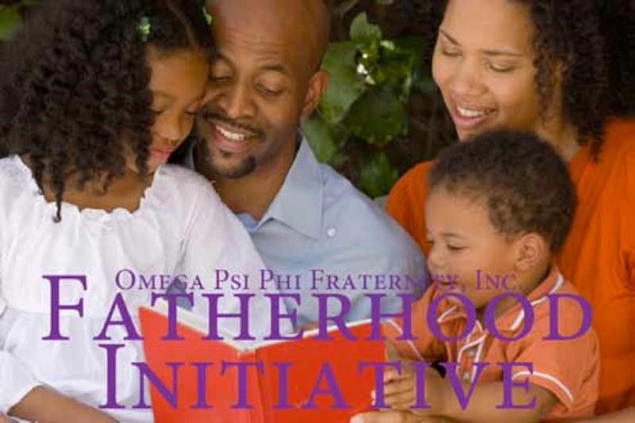

Faithfully Serving,
Donald Williams II
(Retired Army LTC) Executive Director, UCF
Mu Nu Chapter Immediate Past Basileus
Omega Man of the Year (2018)
Montgomery County, Maryland
2nd District, Chairman of the Year (2017)
Fatherhood Initiative and Mentoring Committee
Life Member#8535

